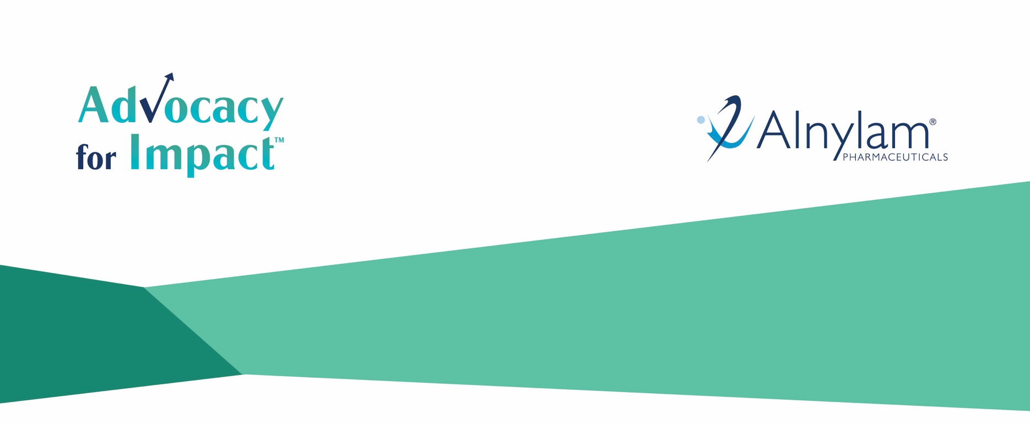

Advocacy for Impact Grants
2019-2020 Grant Application

Alnylam seeks to support patient advocacy groups by giving them resources to bring new projects and ideas to fruition. We encourage patient advocacy groups from around the world to apply with new projects targeted to specifically meet the unique or special needs of their own communities. For full eligibility guidelines, please consult the Application Guide.
To ensure the review of your application, please provide all requested information and complete the application in its entirety. If you have any questions, please direct them to AdvocacyForImpact@alnylam.com.
APPLICATION PREVIEW
You will need to provide:
- Proof of charitable status | - Annual operating budget
- Itemized project budget | - Detailed project timeline

All questions and attachments are required for submission. Any additional documentation submitted that was not specified or requested within this application, will not be considered.

GROUP INFORMATION
GENERAL INFORMATION
1) Group Name (This must match the name that is registered with your government)
2) Address
3) Country
4) Website Address (optional)
MAIN CONTACT INFORMATION
5) Prefix (optional)
6) First Name
7) Last Name
8) Title in the Group
9) Phone Number
10) Email Address
11) Fax

GROUP INFORMATION
12) Year founded
13) What patient population does your group serve?
ATTR Amyloidosis  Porphyria  Primary Hyperoxaluria | Multiple Rare Diseases  Other
14) What geographic location(s) does your group serve?
15) Mission Statement (300 word limit)
BACKGROUND INFORMATION
16) Have you received support from Alnylam within this calendar year? Please note, if you have previously received funding from Alnylam, this does not disqualify your group from being awarded a grant. However, recipients of the 2018 Advocacy for Impact Grants must wait one application cycle before applying again and therefore are not eligible to apply for this year’s cycle. Alnylam is required to track and report all payments made to patient advocacy groups.
Yes | No
16a.) If you answered “Yes” to the question above, how much support was received and for what? If you answered 'No' above, please write "not applicable."

17) Do any public officials, government officials, or government employees currently serve on the group’s Board of Directors? If yes, please identify a) the member, b) their position on the board, and c) what their public or government role is. (Ex: John Smith – Secretary - Mayor of Chicago, IL; John Smith – Chairman - Member of Parliament, Leeds East) If the answer is no, please write “not applicable” in the text box below.
18) Local Currency Code - A currency code is a code that indicates the currency used in your country. Exs: USD, EUR, JPY
ATTACHMENTS: Please include the following attachments when you submit your application.
Attachments should be submitted as a PDF and should be clearly labeled with the title outlined below.
Sample: Annual Operating Budget_ [Name of Organization]
- Annual Operating Budget – please submit your organization’s detailed annual operating budget
- Payee Proof of Charitable Status
- The payee is the group that would receive the money for this application if it is chosen as a recipient.
    - U.S. payee - please upload a copy of your U.S. IRS tax exemption letter showing the Tax ID and tax status or your w-9. Here is a link to a w-9: https://www.irs.gov/pub/irs-pdf/fw9.pdf.
    - Outside of the U.S. - please upload an official government-issued document demonstrating the charitable status of the organization in your country.

PROJECT INFORMATION
19) Project Title:
20) Please indicate which of the following disease area(s) your application is focused.
ATTR amyloidosis
Acute hepatic porphyria
Primary hyperoxaluria type 1
21) Please indicate which funding category your project seeks to impact (must be one or more of the below):
Increase disease awareness and access to diagnosis
Offer education to patients, families, caregivers, healthcare providers and/or public
Improve patient care
22) What is the amount of funding you are requesting (you may request a maximum of $50,000 USD or the equivalent in your local currency)? Please provide the amount in your local currency and specify your currency type. Selected recipients will receive funding amounts based on conversion rates at the time of the payment disbursement.
23) What is the overall budget of this project? Please only provide the total amount and include the currency.
You will be asked to provide a detailed budget as an attachment.
24) If the project will not be fully funded by Alnylam, please describe how you will fund the remaining amount.
If it will only be funded by Alnylam, please write “not applicable.”
25) What geographic region or community will this project impact? Define where (which countries, regions or cities) the project will be executed, as well as which geographic areas will be impacted through the project. (100 words or less)
26) What is the landscape of the disease in the geographic area in which you are working? For example, the level of awareness, government support, number of people affected, accessibility to medical care, challenges or barriers to diagnosis or care, etc. (500 words or less)
27) Please provide a summary of the proposed project, including what makes it new and/or unique. (1,000 words or less)
28) Unmet Need: What is the unmet need within the ATTR amyloidosis, acute hepatic porphyria or primary hyperoxaluria type 1 community the project is designed to impact? (500 words or less)
29) Goals: What are the goals of the project? Summarize the measurable goal(s) of the proposed project. (500 words
or less)
30) Execution: What is the strategy to complete this project? Please outline the following. (1000 or less)
- A detailed written summary of the strategy or approach you will take to complete this project
- Outline your number of employees and volunteer employees/volunteers
- Include a staffing plan for your proposed project
- Outline resources/tools you will use, etc.
31) Evaluation: How will the impact of the project be measured? What are the measures of success of this project and what methods will be used to measure them? Outline the proposed measurement methods and tools used to measure. (1000 words or less)
ATTACHMENTS: Please include the following attachments when you submit your application.
Attachments should be submitted as a PDF and should be clearly labeled with the title outlined below.
Sample: Itemized Project Budget_ [Name of Organization]
- Itemized Project Budget
- Detailed Project Timeline: please outline timing for all project activities from planning to execution and evaluation.

ADDITIONAL REQUEST INFORMATION
TRANSPARENCY AND FINANCIAL DISCLOSURE
Alnylam intends to comply with legal requirements for transparency of interactions with healthcare practitioners and healthcare organizations, consistent with applicable country, state, and federal laws and regulations, and/or the codes
of practice applicable to pharmaceutical industries. Information related to the request and any funding provided to the requester/applicant, including but not limited to, the names of the parties, the amount of any payments or transfers of
value to which the funding relates, (e.g. meals, travels, etc.), (including fees and expenses reimbursed) may be subject to collection and reporting to relevant authorities/institutions and may be publicly disclosed by the Company and/or by its Affiliates and/or by relevant authorities/institutions. As applicable, your acceptance of any funding provided by Alnylam constitutes your consent to any collection reporting and disclosure. This may require working with Alnylam Compliance to ensure all applicable payments are reported. In addition, certain payments to patient organizations may also be required to be reported and publicly disclosed in some countries. In case Alnylam collects your personal data to process the funding request and comply with applicable transparency laws and/or codes, such personal data will be stored and processed by Alnylam in accordance with applicable privacy laws and Alnylam's Privacy Policy. You can find more information on the Alnylam privacy policy on our corporate website www.alnylam.com. Should you wish to exercise your access rights to your personal data, please contact our DPO at privacy@alnylam.com.
ATTESTATION
I affirm that the recipient of this grant funding is not involved in therapeutic decisions related to Alnylam products (e.g. prescribing, purchasing or recommending for use).
Signature:
ADDITIONAL REQUEST INFORMATION
Under U.S. Federal Transparency requirements, all payments and other transfers of value to U.S. licensed physicians and teaching hospitals must be collected for potential report to CMS. Any payments or transfers of value, which your organization provides to a Covered Recipient, must be reported to Alnylam.
1) Applying Organization and Partner (if applicable) are aware of the current laws related to aggregate spend reporting including US Federal Sunshine Act (42CFR Parts 402 and 403) and US state laws.
Yes | No
2) If awarded, will funds from this contribution be used to pay a healthcare professional (Physician) speaker?
Yes | No
3) Is there any other transfer of value being given to physicians or healthcare organizations? Examples include food or beverage, reprints and other items or materials provided to attendees (e.g. note pads etc.). Payments, including, but not limited to honoraria, travel expenses, research funding, faculty or speaker fees.
Yes | No

PRIVACY NOTICE
By entering your details on this questionnaire, you hereby consent to the processing of any personal information you have included in the questionnaire for the purpose of applying for an Advocacy for Impact grant, and you confirm that you have the relevant rights and/or permissions to provide such personal information to Alnylam. Information provided by you may be transferred to other third parties for processing, such as the authorized consultants of Alnylam, service providers of Alnylam (or other carefully selected third-party organizations authorized by Alnylam, together, referred to as "Third Parties") exclusively for the purpose of administering this grant request. Alnylam will require these Third Parties to whom it discloses information you have provided to protect such information using substantially similar standards to those required by Alnylam, including an obligation on those Third Parties to use appropriate technical, administrative and physical safeguards to protect information you have provided from loss, misuse or alteration. Alnylam also requires that such Third Parties do not use information you have provided for any purpose that is not specifically authorized by Alnylam. The data that we collect from you will be transferred, stored and otherwise processed in the United States, a country in which the level of data protection may not be the same as the one afforded in your country of residence and/or in the European Economic Area. Where such international transfers take place, Alnylam ensures that appropriate safeguards are in place to ensure the adequacy of data protection of your personal information as well as the security of the processing in the recipient countries. Alnylam shall process your personal information in accordance with the Alnylam Privacy Statement, available at https://www.alnylam.com/privacy-policy/.
CONSENT
I consent to the transferring, storing and otherwise processing of any personal information I have included in the questionnaire for the purpose of submitting an Advocacy for Impact grant request.
Check box to consent
Or Signature:
I confirm that I have the relevant rights and / or permissions to provide such personal information to Alnylam.
Check box to confirm
Or Signature:
Please submit this completed form and your attachments in PDF format to AdvocacyForImpact@alnylam.com.
All submissions should include the following subject line: AFI Application - [Name of Organization], [Country].
All attachments must be clearly labeled and provided as a PDF format. Click here for more information on saving
files as a PDF.

